“Sign In” Screen



“Sign In” Screen when username is already in use

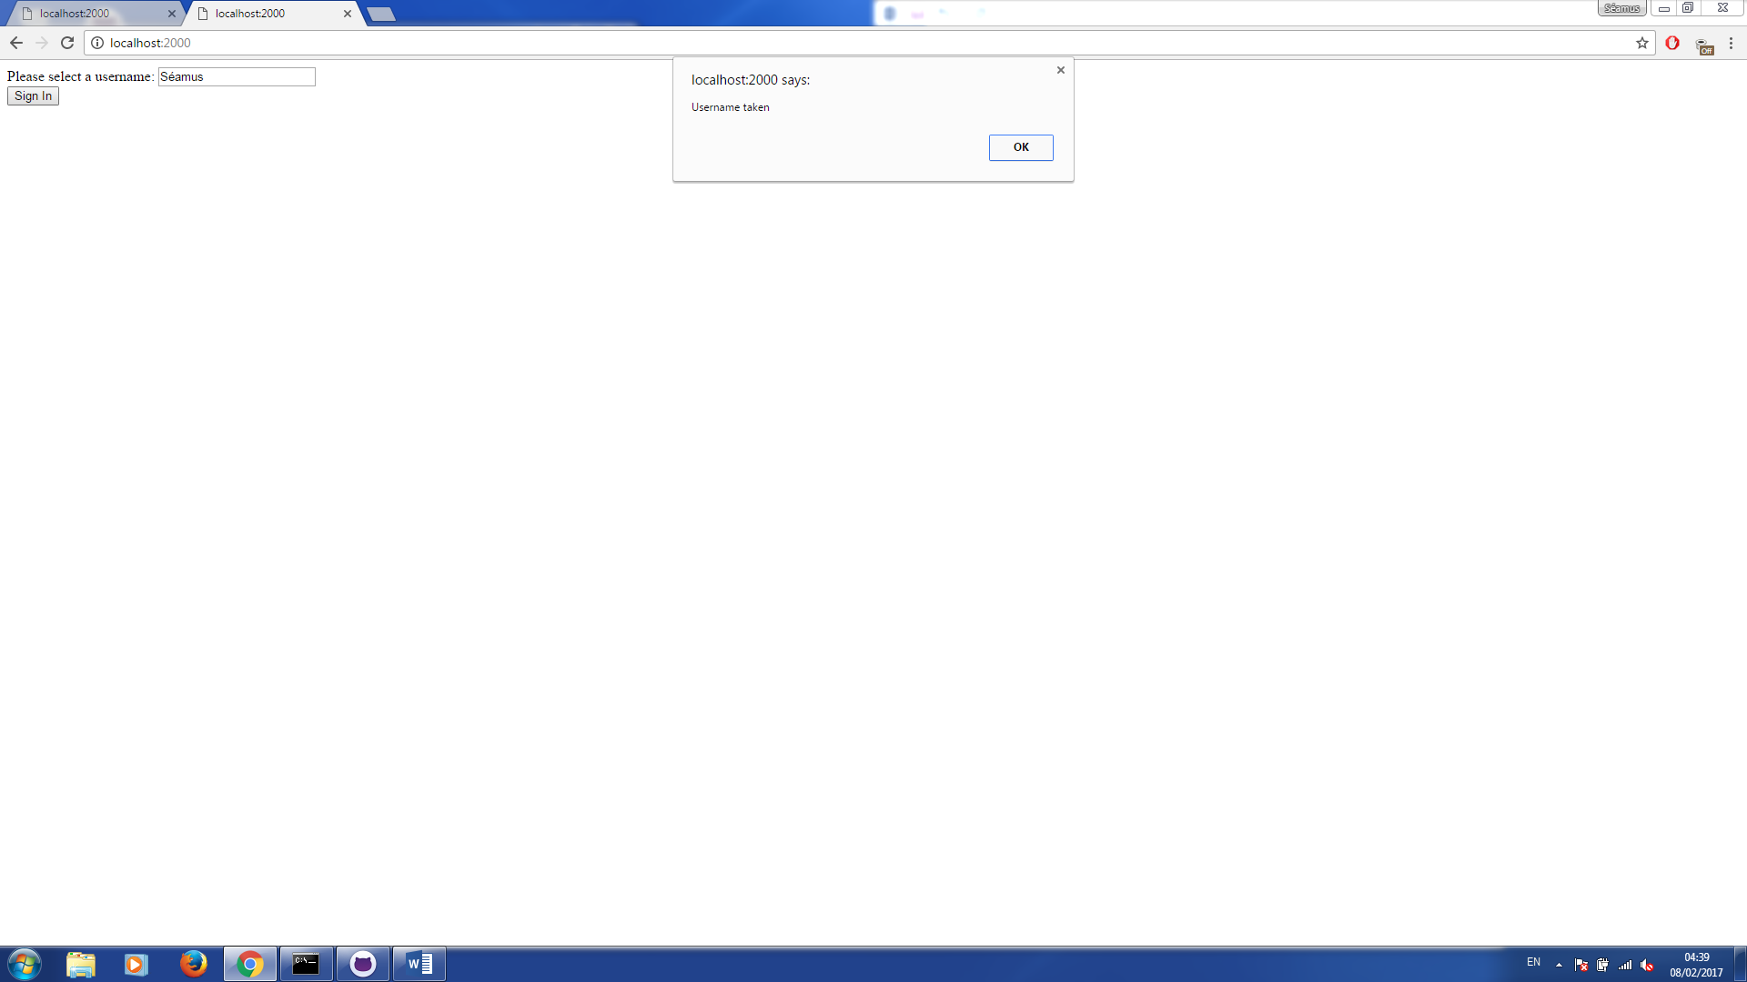

Chat in use between two clients below the space reserved for the game canvas

